

Links to Learning

It’s that time of year again, and we are very excited to announce that we have increased our Links to Learning budget and the individual proposal amounts to $800. Let us help fund your projects, learning tools, field trips and valuable student opportunities.

In an effort to allow more time in the spring to write the proposals and submit the applications,

**The Links to Learning Application is available online beginning March 8, 2024.**

You may submit two proposals of $800 each. Or you may submit an $800 proposal and a $2,000 building proposal. Only ONE $2,000 building proposal may be submitted per school. Please see the informational letter for details.

**Submit a Links to Learning application to the CPS Business Office at Aslin by Thursday, September 5 at 4:30 PM. This deadline is FIRM.**

The Information letter and Application are available online at [www.cpsk12.org\Business Services\Grants\Links to Learning Program](https://www.cpsk12.org/almm) ([www.cpsk12.org/almm](http://www.cpsk12.org/almm))

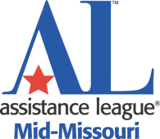

Brought to you by the Assistance League® of Mid-Missouri